Step 1: Create a Jenkins Job

Let’s start by creating a new Jenkins job. Click on the “New Item”, give it a name, pick the “Pipeline” option and click on the OK.

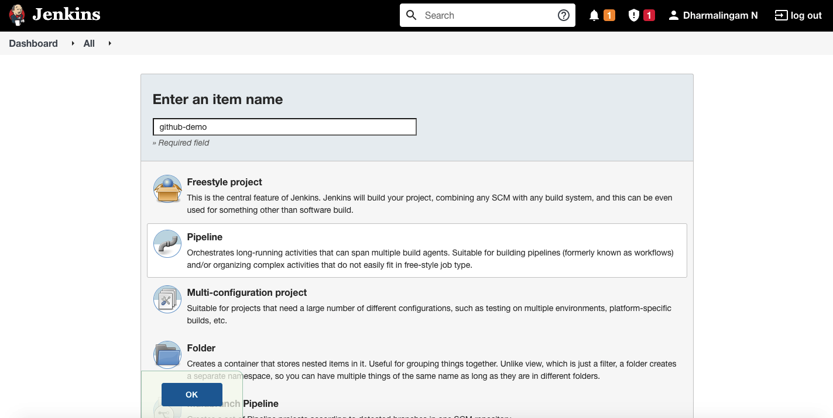

Step 2: Configure GitHub Hook Trigger

On the configuration page, scroll down until the section “Build Triggers” and select the option “GitHub hook trigger for GITScm polling”

Note: We are going to setup this pipeline to trigger whenever a new commits happens on Github repository.

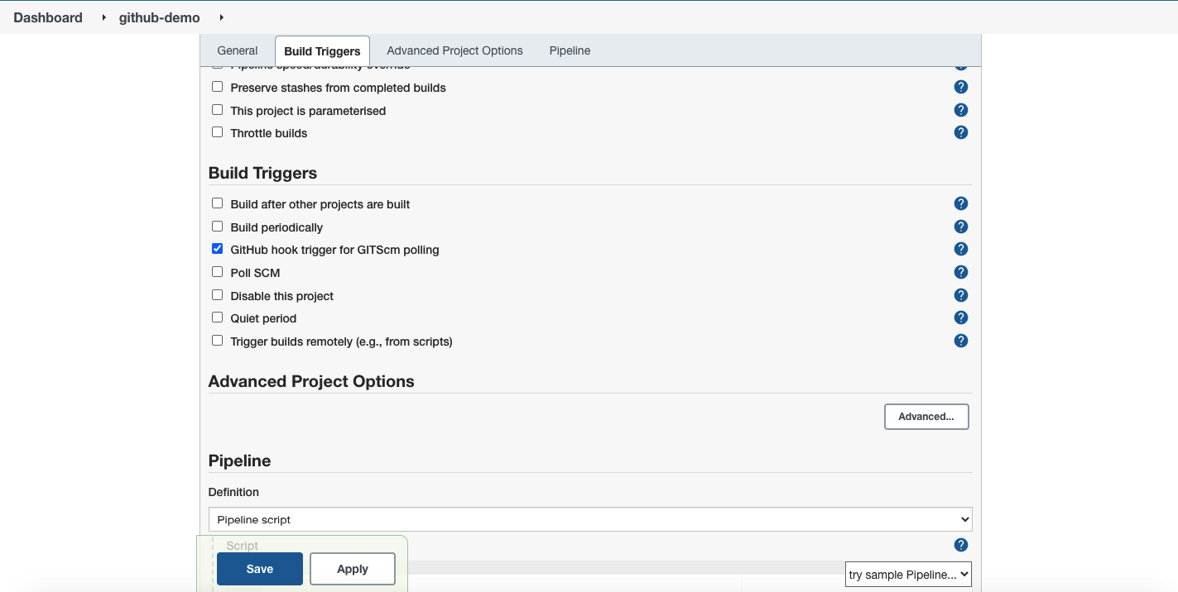

Step 3: Create a GitHub Repository

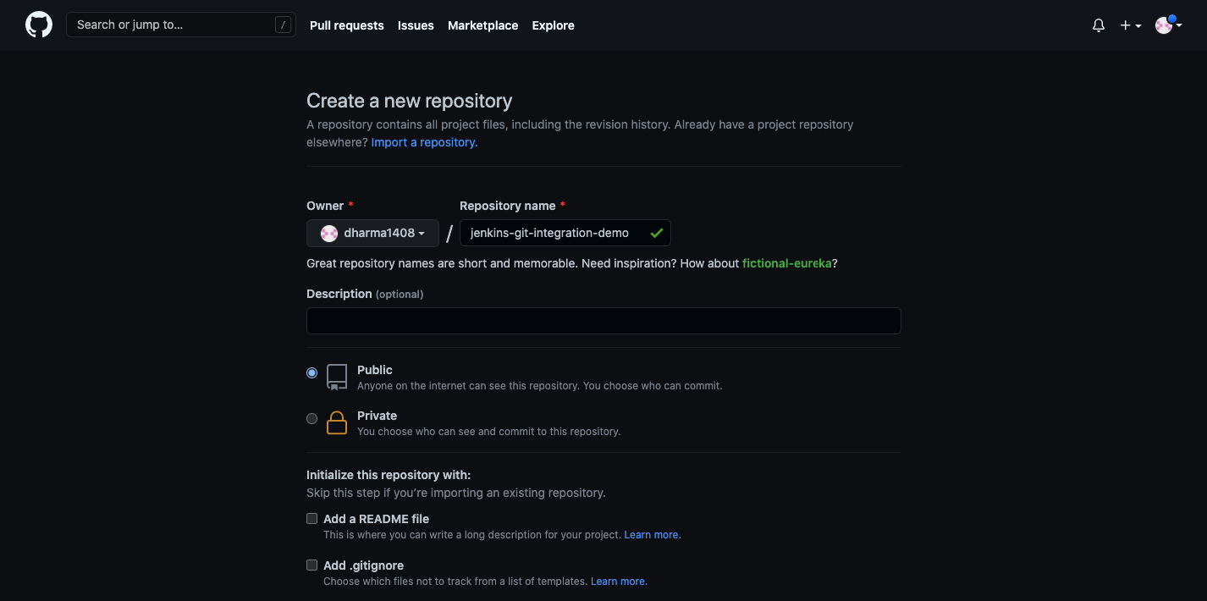

Step 4: Connect a GitHub Repository

Scroll down to the “Pipeline” section. We will configure Jenkins to use GitHub repository as source. Select “Pipeline Script from SCM” under the definition option.

From SCM dropdown, select “git”.

In the repository URL section, paste the GitHub repository URL which you want to use for this pipeline. In my case, I am using the repository which I have created in the previous step.

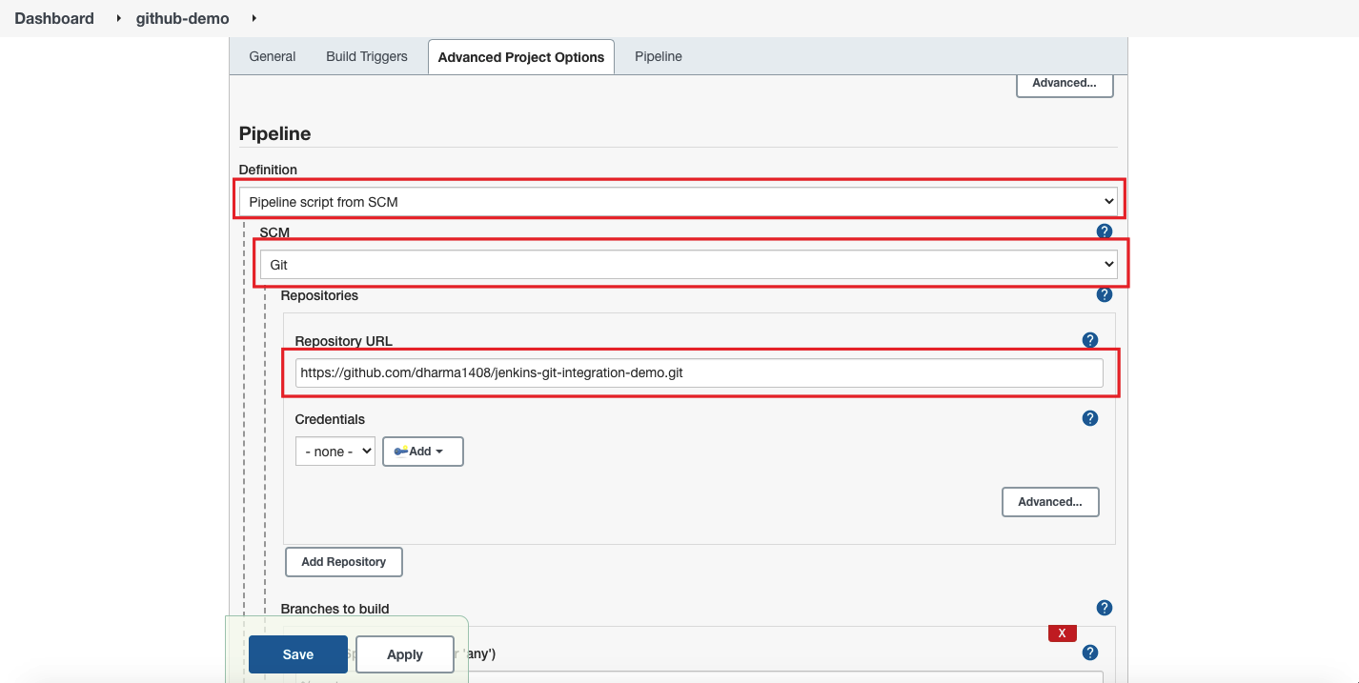

Type the Jenkinsfile path and click on save.

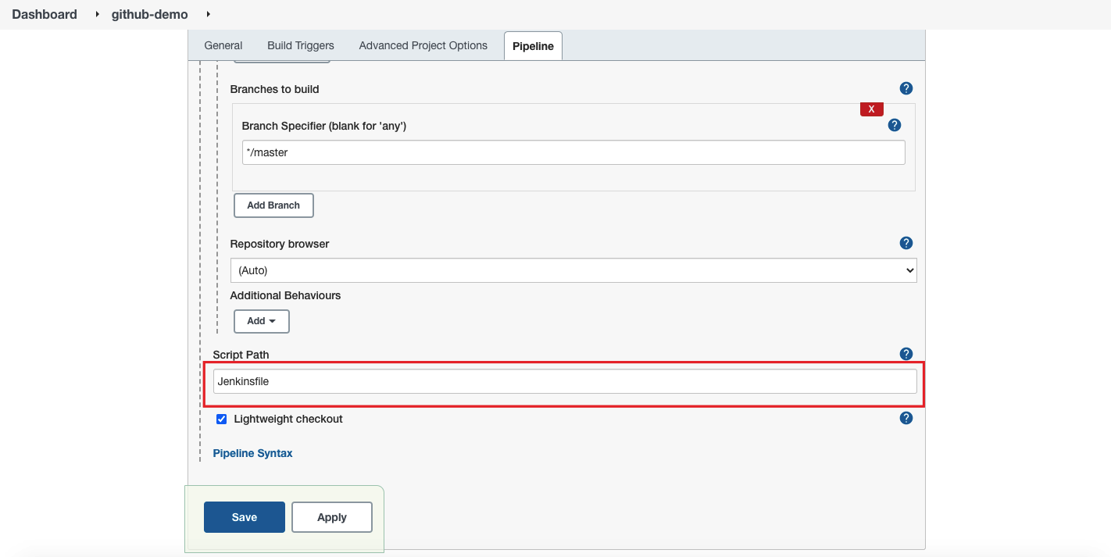

Step 5: Adding a WebHook in GitHub

Login to GitHub and go to the repository which you have connected in the previous step.

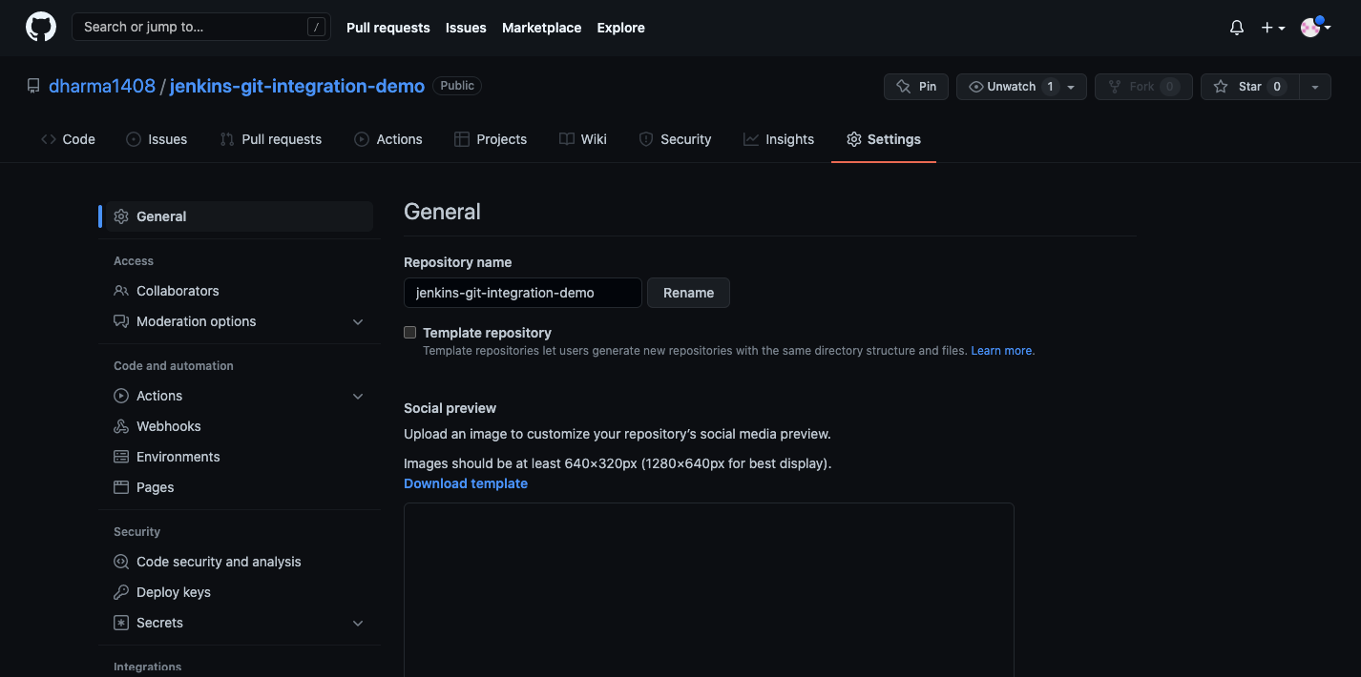

Click on “WebHooks” and then click on “Add WebHooks”.

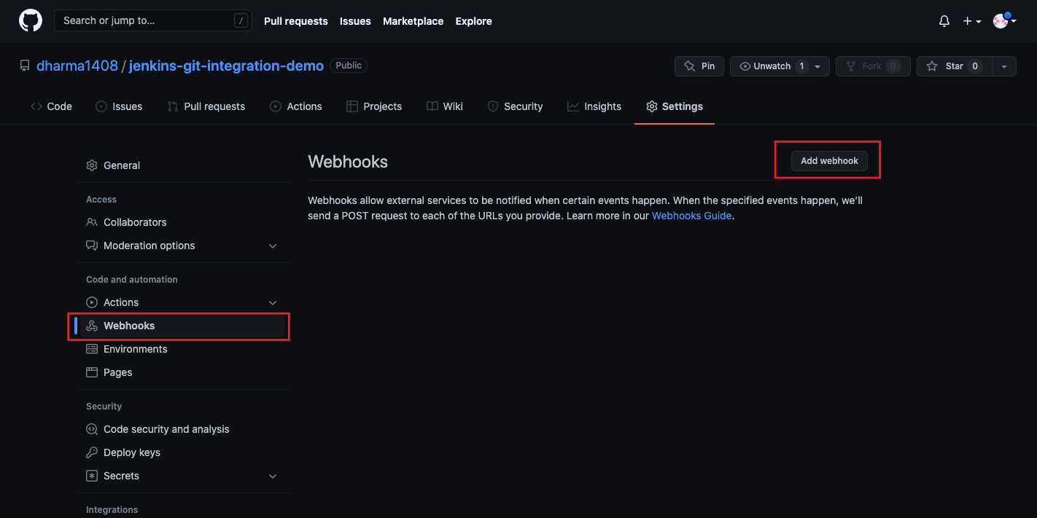

In this page, we will configure Jenkins URL so that GitHub will call Jenkins for the actions. In the “Payload URL” section, enter Jenkins server URL which is accessible over the public internet.

In the content type dropdown, select the option “application/json”. Leave the remaining fields as it it click on Add Webhook. You will see a message stating that the Webhook has been created.

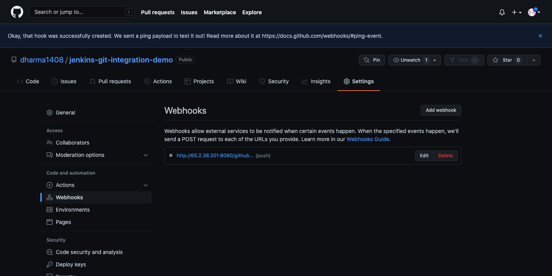

Step 6: Manually Building Jenkins Job

Now go back to the Jenkins dashboard and click on the Job which we have created and then click on “Build Now” from the left.

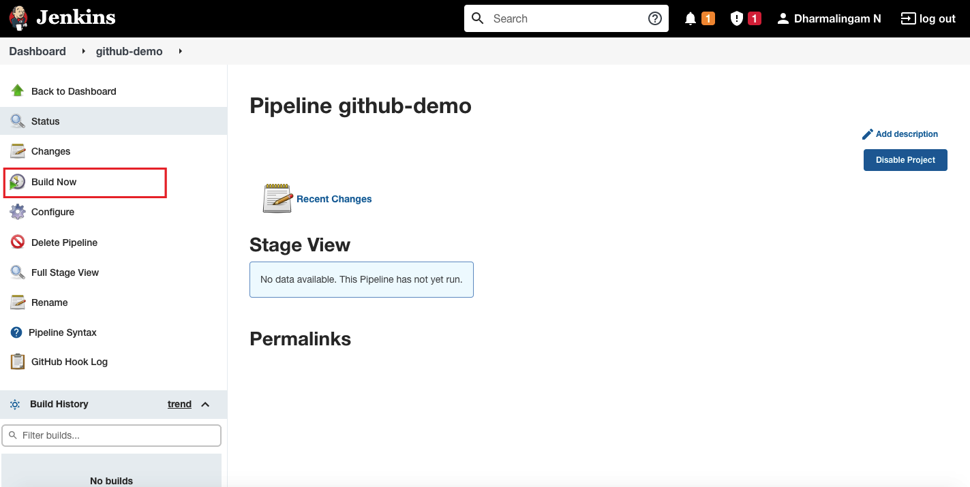

Step 7: Trigger Build with GitHub Commit

Go to your GitHub repository and add a new commit by making any changes and within few seconds, you can see the build is running on the Jenkins dashboard.